

**THE NEWS FLASH RESOURCE PACK**

**December 2021**

**ISSUE #59**

**TEACHERS**

[**www.newsmagmedia.ie**](http://www.newsmagmedia.ie)

**CHILDREN**

[**www.theprimaryplanet.ie**](http://www.theprimaryplanet.ie)

**Copyright © News Mag Media Limited 2021. All rights reserved. If you or your school are not a paid subscriber, neither the whole of this publication nor any part of it may be reproduced, photocopied, stored in a retrieval system or transmitted in any form or by any means without the written permission of the publishers News Mag Media. To subscribe, or for more information, email** [**padraig@newsmagmedia.ie**](mailto:padraig@newsmagmedia.ie)

**THE NEWS FLASH RESOURCE PACK**

**Word Workout**

**We give you the meaning, you find us the word.**

Find the page, article or paragraph in News Flash and find the words to match the meanings given below. The number of letters and the starting letter of the solution are in brackets after each clue.

**LOCATION, Article/Paragraph** **CLUE (number of letters, first letter)**

1. P3 … official NASA spacesuit dressed in an unusual way (6,d)
2. P4 … time of 3:41.02 a competitor (9,o)
3. P6 … to England to make a hole in something (7,p)
4. P10 Norway harmless trouble. (8,m)
5. P15 … and Somalia not an island (8,m)
6. P18 Point 3 animal that gives birth to live young (6,m)
7. P20 someone who designs buildings (9,a)
8. P22 Perfect autumn to make longer (6,e)

**Your answers In alphabetical order**

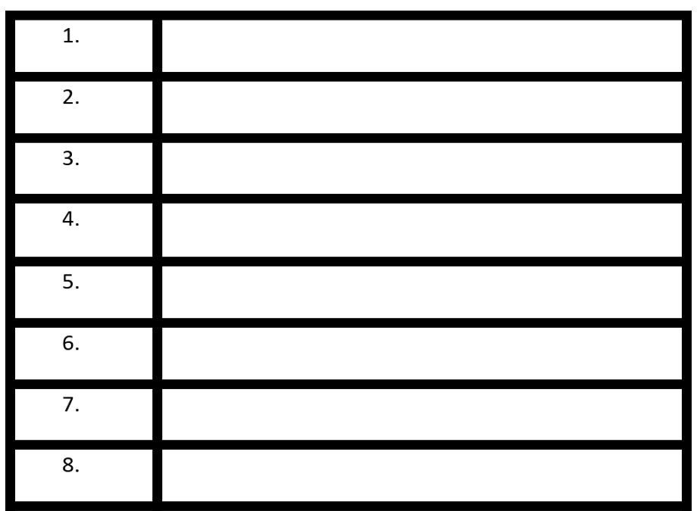

**THE NEWS FLASH RESOURCE PACK**

**Word Workout**

**We give you the meaning, you find us the word.**

Find the page, article or paragraph in News Flash and find the words to match the meanings given below. The number of letters and the starting letter of the solution are in brackets after each clue.

**LOCATION, Article/Paragraph** **CLUE (number of letters, first letter)**

1. P3… biggest ever spud dug up (9,u )
2. P5 … Earth’s surface instruments that record earthquakes (12,s)
3. P7… the question a friendly and organised argument (6,d)
4. P10 Iceland belief passed down from generation to generation (9,t)
5. P15 Flash Facts inactive or asleep (7,d)
6. P18 Point 7 an animal that preys on other animals (8,p)
7. P20 another word for wood (6,t)
8. P22 Katie Faces … another word for fight (4,b)

**Your answers In alphabetical order**



**THE NEWS FLASH RESOURCE PACK**

**Word Workout**

**We give you the meaning, you find us the word.**

Find the page, article or paragraph in News Flash and find the words to match the meanings given below. The number of letters and the starting letter of the solution are in brackets after each clue.

**LOCATION, Article/Paragraph** **CLUE (number of letters, first letter)**

1. P4…of the waterway filled with rubbish (8,p)
2. P5 Migrating Crabs to do with the moon (5,l)
3. P8 French Nativity animal skin for writing or painting on (6,v)
4. P12 Point 2 to show or uncover (6,r)
5. P15 Flash Facts nearly extinct (10,e)
6. P19 Point For example (8,i)
7. P20 point 5 a 3D triangular shape (7,p)
8. P22 Look at your Watch vert very strange and unusual (7,b)

**Your answers In alphabetical order**



**THE NEWS FLASH RESOURCE PACK**

**So Many Mistakes**

**Read through the article taken from this month’s issue and see if you can spot the 8 spelling mistakes.**

**Earthquakes in Scotland**

Scotland experienced its secand earthquake in less than a week on Friday November 19 at 09.29. The British Geological Survey (BGS) said that a 2.2 magnitude earthquake was registered just ootside Roybridge, in the Scottish Highlands. The BGS said the tremor happened at a dept of 7.5km below the surface.

A 3.3 magnitude earthquake was reported by the BGS just before 02:00 on Tuesday November 16. Its epicentre was located about 140km north-west of Glasgow.

More than 30 people reported that they had felt a tremer, with reports coming from as far as Edinburgh in Scotland, and Ballycastle in Co. Antrim. The earthquake also registered on all the seismographs (instruments that record and measure earthquakes) across Ireland. That quake happend 10km below the Earth's surfase.

Data from the BGS shows that between 200 and 300 earthquakes are detected in the UK every year. Geological Survey Ireland (GSI) Director Dr Martin Mollhoﬀ said: ‘In 40 yeers we have only recorded around 200 earthquakes in Ireland. The largest was a 2.4 magnitude quake in Buncrana, Co. Donegal. We have never recorded anyting larger onshore.’

**Misspelt words Correct Spellings**



**THE NEWS FLASH RESOURCE PACK**

**So Many Mistakes**

**Read through the article taken from this month’s issue and see if you can spot the 8 spelling mistakes.**

**Djibouti**

Djibouti (pronounced Ji-boot-ee) is on the Horn of Africa on the north-eastern cost of the continent, by the Bab-el-Mandeb Strait, which seperates the Gulf of Aden from the Red See. It is the third smallest country in maynland Africa and is bordered by three other countrys – Eritrea, Ethiopia and Somalia.

Djibouti is at the southern entrance to the Red Sea, which is one of the world’s busyest shipping lanes. Ships carrying cargo between Europe and Asia sail through the Red Sea and the Suez Canal witch connects it to the Mediterranean Sea. Djibouti City has one of the busiest modern ports in the world. Though Djibouti has almost no exports, Ethiopia and Somalia import and export most of there goods through Djibouti.

**Misspelt words Correct Spellings**



**THE NEWS FLASH RESOURCE PACK**

**Fill in the Blanks**

**Read through the words in the Word Bank first, then read the article. Make sure you think about the best place to put a word, not the first place. Take your time as some words may fit in more than one place, so choose carefully.**

**The ISS (Part I)**

The International Space Station (ISS) is a large __________ which is in orbit around Earth. Crews of astronauts and cosmonauts (Russian astronauts) live and work on it. Several __________ worked together to build and then use the space station.

**WORD BANK**

countries

years

crew

spacecraft

largest

station

shuttle

space

The ISS was built with parts that were made on Earth but assembled in __________ by astronauts. Most missions used NASA's space __________ to carry up the heavier pieces.

The ISS is the _________ structure ever built in space. It weighs around 42 tonnes (more than 320 cars) and is 109m long.

The ﬁrst piece was launched in November 1998. More pieces were added over the next two ________ before the station was ready for people to live and work there.

The ﬁrst ______ arrived on November 2, 2000. People have lived on the space _________ ever since. More pieces have been added over time and it was completed in 2011.

**THE NEWS FLASH RESOURCE PACK**

**Fill in the Blanks**

**Read through the words in the Word Bank first, then read the article. Make sure you think about the best place to put a word, not the first place. Take your time as some words may fit in more than one place, so choose carefully.**

**The ISS (Part II)**

The living __________ on the ISS are all together larger than a 6-bedroom house but long and narrow. There are 6 sleeping quarters, 2 bathrooms, a gym, a galley (kitchen) and a large domed window called the Cupola.

**WORD BANK**

average

telescope

quarters

responsible

muscles

spaceships

fix

distance

The ISS has laboratories from the United States, Russia, Japan and Europe. Crews are not only ___________ for science, but also need to carry out repairs to the station. Sometimes, they must go out on spacewalks to ______ problems.

The ISS ﬂies at an __________ altitude of 400km above Earth. It circles the globe every 90 minutes at a speed of about 28,000km/h. It travels about the same __________ it would take to go from Earth to the Moon and back every day.

You can see the ISS orbit the Earth without having to use a __________. It is the second brightest object in our night sky, after the Moon.

Six ____________ can dock at the ISS at any one time.

Astronauts have to work out for two hours a day while on board to help keep their ________ in shape.

**THE NEWS FLASH RESOURCE PACK**

**Weekly Quiz Answer Sheet**

|  |  |
| --- | --- |
|  |  |
|  |  |
|  |  |
|  |  |
|  |  |
|  |  |
|  |  |

This activity can be completed online at [www.newsflash.ie](http://www.newsflash.ie) ©News Mag Media 2021

**THE NEWS FLASH RESOURCE PACK**

**Quiz 24**

**This month's 24-quiz is based on the 24 pages of TPP. E.g. The answer to Q.7 can be found on page 7.**

1. Which movies is featured in a free mini-mag this month?

2. What animals is featured in Awesome Animal Facts this month?

3. What unusual toy has been added to the US Toy Hall of Fame?

4. Which town was awarded ‘Ireland’s Tidiest Small Town’ ?

5. How old is Hurricane Hawkins?

6. What year did Speke go to India with the British Army?

7. What invaded Speke and Burton’s camp on their travels?

8. Which animal looks to be nibbling Joseph’s halo?

9. What is a turcaí ?

10. What unusual food do the Japanese have on Christmas day?

11. Who played The Grinch in the 2000 live-action version of the classic?

12. How often do you open a door on an advent calendar?

13. How many times has it snowed on Christmas Day in Ireland since 1961?

14. Why are there only 25 quiz questions when there are 31 days in December?

15. What is special about Lake Assal?

16. What is the other name for St Stephen’s Day?

17. What can you win every week by taking part in the News Flash Quiz?

18. What is a giraffe’s favourite food?

19. What is ‘the secret sauce to a happy life’?

20. When did the concert hall open?

21. When was SIMS first released?

22. Where are the Ireland rugby team currently ranked in the world?

23. What has changed for the All-Irelkand finaks at Croke Park for 2022?

24. What colour is the dog’s scarf?

**THE NEWS FLASH RESOURCE PACK**

**Word Search**

**There are 21 words hidden but only 20 are listed below. Can you find the mystery word?**

*Clue – Great Little Helpers*

1. Stockings
2. Family
3. Mass
4. Toys
5. thankful

6. feast

7. cards

8.poinsetta

9.carols

10. presents

1. Tree
2. Holly
3. Mistletoe
4. Wreath
5. Candles
6. Ornaments
7. Angels
8. Yule logs
9. Gingerbread
10. Star

**THE NEWS FLASH RESOURCE PACK**

**Sudoku**

**Each of the 9 boxes must contain the numbers 1 – 9. When you ﬁll them in, you will then see that each line going across and each line going down also contains the numbers 1 – 9.**

**THE NEWS FLASH RESOURCE PACK**

**Design a Poster**

|  |
| --- |
|  |

**Design a poster to show what kinds of things you can do at school to help out. You can use the ideas from this issue, or you might have some reasons of your own. Remember to make your ideas clear and easy to read.**

**THE NEWS FLASH RESOURCE PACK**

**Crack the Joke**

**In this month's Crack the Joke on Page 17, a funny joke is waiting to be cracked. When you solve the code and reveal the gag, see if you can come up with a drawing/illustration that you think best captures the joke.**

|  |
| --- |
|  |

**THE NEWS FLASH RESOURCE PACK**

**Have Your Say**

**Based on articles from this month's mag, we want you to think about some of the issues that arise. Remember, when you are trying to put forward an opinion, or an argument, make sure you know your facts and figures and be clear in how you feel about a certain topic and why. Here are some questions and statements you and your class might like to consider thinking about and discussing. Some you will agree with, some you clearly won't!**

|  |
| --- |
| 1. My parents don’t want me to help out at home. |
| 2. Moving the All-Ireland finals to the summer was a terrible idea. |
| 3. All children should sleep until at least 10 am on Christmas morning |
| 4. Giant dog breeds are scary. |
| 5. Measuring earthquakes and keeping records is a waste of time |
| 6. I would be proud if my town won ‘tidiest town in Ireland’. |
| 7. I’d love to visit Christmas Island when the crabs migrate. |
| 8. Sand is not one of the best things to play with. |

**THE NEWS FLASH RESOURCE PACK**

**Did You Know?**

**Every issue of your News Flash is packed full of facts and ﬁgures. Why not record the top 4 things that you learned from this issue. When you do, make sure to draw an illustration to go with each one. When you are ﬁnished, share and discuss your choices with your classmates. We have added our favourite one below. You’ll see I didn’t just copy it from the book, I wrote it out in my own words. Always a great idea when doing a project.**

|  |
| --- |
| Did You Know?  Did you know that NASA use teddies to test gravity in space? I think it’s a great idea and a super safe way to carry out the test without injuring anyone or breaking anything in the spaceship. |
| Did You Know? |
| Did You Know? |
| Did You Know? |
| Did You Know? |

**THE NEWS FLASH RESOURCE PACK**

**What’s in the News?**

**How well have you read this month's paper? Here, in Question Time, as well as testing your memory and retention skills, we also test your imagination and creative skills. We base this activity on our News Round section. Read the articles and answer the following questions.**

1. Read the Picture Special. Where was the giant potato found?

_______________________________________________________________________________________________

1. Read the Picture Special. Who was the previous dog World Record winner and how many balls could be hold in his mouth?

_______________________________________________________________________________________________

1. Read the article ’Sharks in the Thames’. How many species of sharks live in the Thames and what are they?

_______________________________________________________________________________________________

1. Read the article about Ronnie Delany. Where was the statue unveiled and why is Ronnie being celebrated?

_______________________________________________________________________________________________

1. Read the article ‘Earthquakes in Scotland’. How many earthquakes have been recorded in Ireland in the last 40 years, and what size was the largest?

_______________________________________________________________________________________________

1. Read the article ‘Christmas Island’s Migrating Crabs’. Why do the crabs need to stay moist?

_______________________________________________________________________________________________

**THE NEWS FLASH RESOURCE PACK**

**Know Your Sport**

**How well have you read this month's sports news? Here, in Know Your Sport, we’re testing your memory and retention skills. We base this activity on the pages from our sports section. Read the articles and answer the following questions.**

1. Read the article ‘Vikki’s Victories’. Which club does Vikki Wall play for?

_______________________________________________________________________________________________

1. Read the article ‘Perfect Autumn for Ireland’. How many times has Ireland beat New Zealand?

_______________________________________________________________________________________________

1. Read the article ‘Look at your watch, Ref’. How many injury time minutes did the players have to play before the official start of the second half?

_______________________________________________________________________________________________

1. Read the article ‘Mullins heads for Oz’. Why is Oisín Mullin going to Australia?

_______________________________________________________________________________________________

1. Where is Geelong located?

_______________________________________________________________________________________________

1. Read the article ‘Summer Finals in Croke Park’. When was the last time there was an All-Ireland final in July?

_______________________________________________________________________________________________

1. Who won that final on July 5th, 1908?

_______________________________________________________________________________________________

1. Read the article ‘Man. Utd. Sack Solskjaer’. How many years did Ole spend as a player for the club?

_______________________________________________________________________________________________

**THE NEWS FLASH RESOURCE PACK**

**Answers**

**Word Workout**

#1 #2 #3

1. decked
2. opponents
3. pierced
4. mischief
5. mainland
6. mammal
7. architect
8. extend
9. polluted
10. lunar
11. vellum
12. reveal
13. endangered
14. instance
15. pyramid
16. bizarre

1. unearthed

2. seismographs

3. debate

4. tradition

5. dormant

6. predator

7. timber

8. bout

**So Many Mistakes**

#1 #2

1. coast

2. separates

3. sea

4. mainland

5. countries

6. busiest

7. which

8. their

1. second

2. outside

3. depth

4. tremor

5. happened

6. surface

7. years

8. anything

**Fill in the Blanks**

#1 #2

1. spacecraft

2.countries

3.space

4.shuttle

5.largest

6.years

7.crew

8.station

1. quarters

2.responsible

3.fix

4.average

5.distance

6.telepsocpe

7.spaceships

8.muscles

**THE NEWS FLASH RESOURCE PACK**

**Quiz 24**

17. A selection box

18. Acacia leaves

19. Helping others

20. October 24th, 2003

21. January 31st, 2000

22. 4th

23. They will be in July

24. Yellow

9. turkey

10. KFC

11. Jim Carrey

12. everyday

13. 17 times

14.Christmas is the 25th

15. It is a saltwater lake

16. Boxing Day

1. Clifford the Big Red Dog
2. Giraffes
3. Sand
4. Abbeyleix, Co Laois
5. 105 years old
6. 1844
7. Beatles
8. The donkey

**Sudoku**

**What’s in the News? Know Your Sport**

1. New Zealand

2. Augie – 5 balls

3. 3: tope, starry smooth-hound & spurdog

4. Arklow Co. Donegal; he’s an Olympic gold -medallist

5. 200 earthquakes; biggest was 2.4 magnitude

6. To stay alive

1. St Peter’s Dunboyne
2. 3
3. 4 minutes
4. To play Aussie rules for the Geelong Cats
5. Australia in the state of Victoria
6. 113 years ago
7. Dublin
8. 11 years

**THE NEWS FLASH RESOURCE PACK**

**Wordsearch (mag)**

**Spot the Difference**

**True or False**

1. The largest bird in the world is the bald-headed eagle. FALSE. It is the ostrich
2. Male ants can fly. TRUE!
3. St Stephen’s Day is also called Boxer Day. FALSE! It’s called Boxing Day
4. An octopus has three hearts. TRUE!
5. The rainbow is made up of almost a million colours. TRUE!

**THE NEWS FLASH RESOURCE PACK**

**Wordsearch (resource pack)**

**Crack the Joke**

What is the best Christmas present in the world?

***A broken drum - you just can’t beat it!***

**Cúinne na Gaeilge**

